Course Specialist Year 12 Test One 2022

Student name: ________________ Teacher name: ________________

Task type: Response

Time allowed for this task: _____40______ mins

Number of questions: _____8______

Materials required: Calculator with CAS capability (to be provided by the student)

Standard items: Pens (blue/black preferred), pencils (including coloured), sharpener, correction fluid/tape, eraser, ruler, highlighters

Special items: Drawing instruments, templates, notes on one unfolded sheet of
A4 paper, and up to three calculators approved for use in the WACE examinations

Marks available: __42____ marks

Task weighting: _10___%

Formula sheet provided: Yes/No

Note: All part questions worth more than 2 marks require working to obtain full marks.

Q1 (2, 3 & 3 = 8 marks)
Let and .
Simplify the following.

Solution
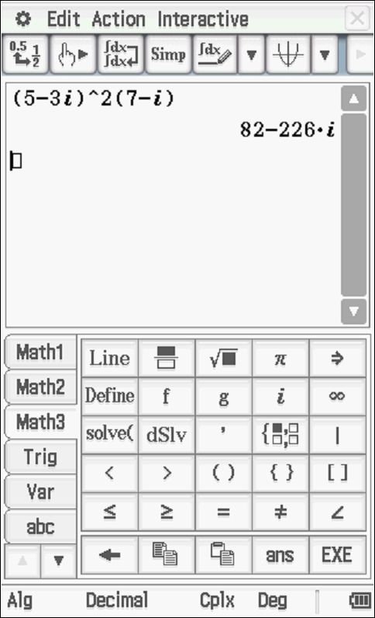

Specific behaviours
✓ real part
✓ imaginary part

Solution
Specific behaviours
✓ shows use of conjugate
✓ numerator
✓ denominator

Solution
Specific behaviours
✓ shows use of conjugate or uses result from b but only if conjugate shown
✓ shows how to multiply numerators
✓ simplified expression

Q2 (3 marks)
Determine all possible real number pairs such that

Solution
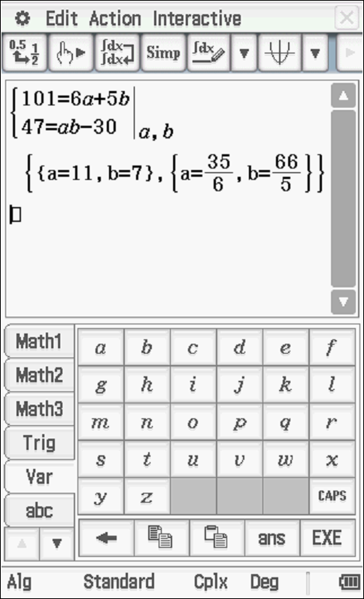

Specific behaviours
✓ equates real and imaginary parts of two expressions
✓ sets up two simultaneous equations
✓ solves for two exact pairs of values

Q3 (3 marks)
Consider the polynomial where are real numbers.
Given that and determine the values of .

Solution
Specific behaviours
✓ uses conjugate root
✓ solves for one constant
✓ solves for all 3 constants

Q4 (3 marks)
Using the diagram below determine the complex number in exact cartesian form.
(Note: Not drawn to scale)
Solution
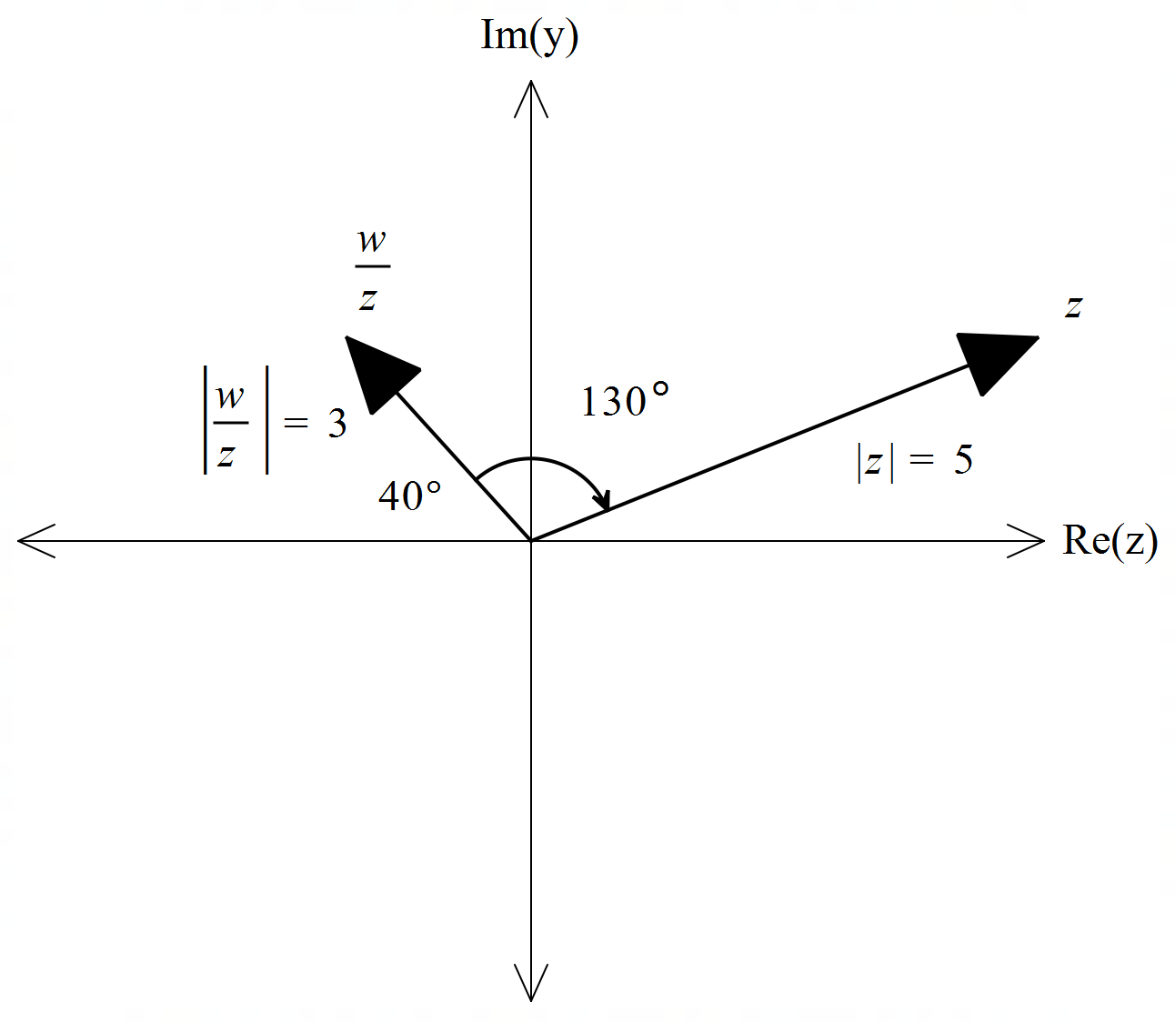

Specific behaviours
✓ determines argument of w
✓ determines modulus of w
✓ expresses in exact cartesian form

Q5 (3 & 3= 6 marks)
Sketch the locus for the following labelling important features and points.

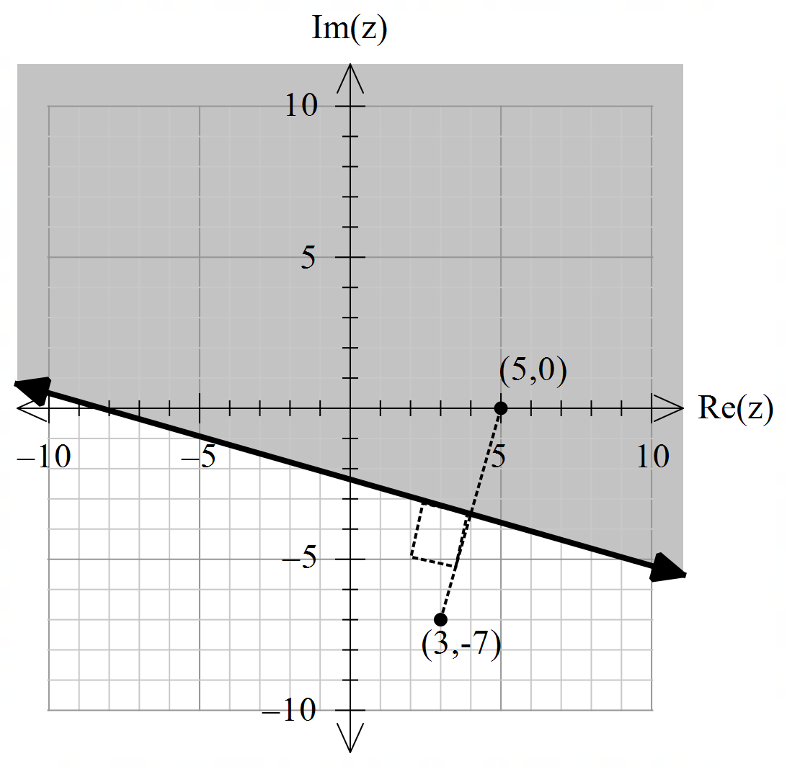

Solution
Specific behaviours
✓ plots endpoints
✓ draws perpendicular bisector & indicates right angle
✓ shades correct region

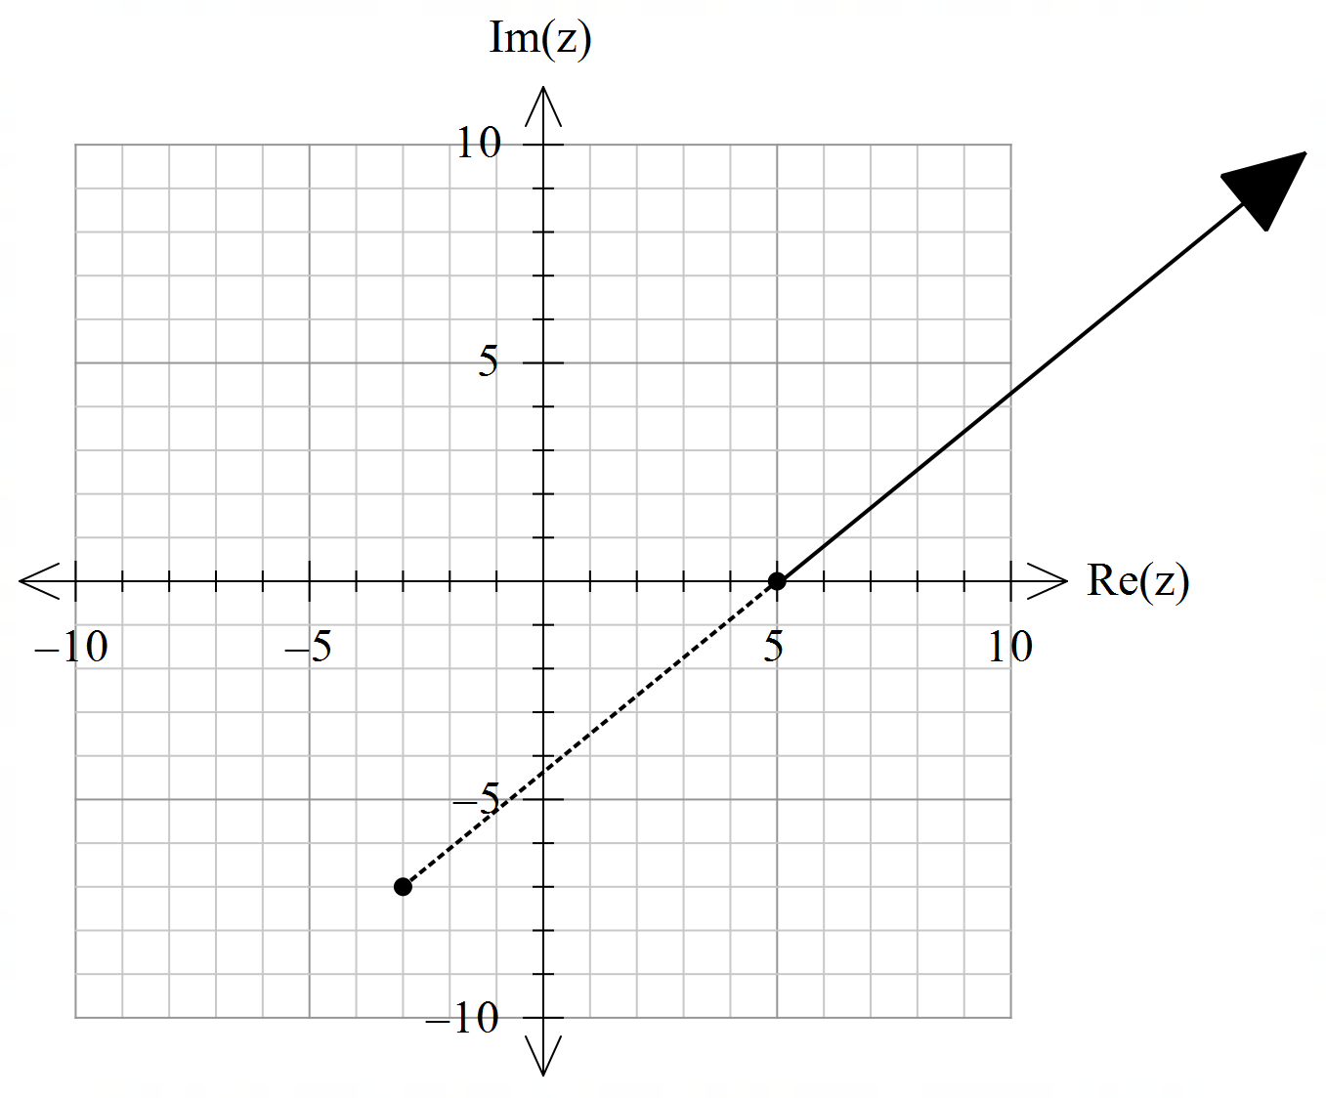

Solution
Specific behaviours
✓ plots pts (-3,-7) & (5,0)
✓ shows dotted line between
✓ plots locus line

Q6 (2 & 4 = 6 marks)
Consider the set of points in the complex plane such that .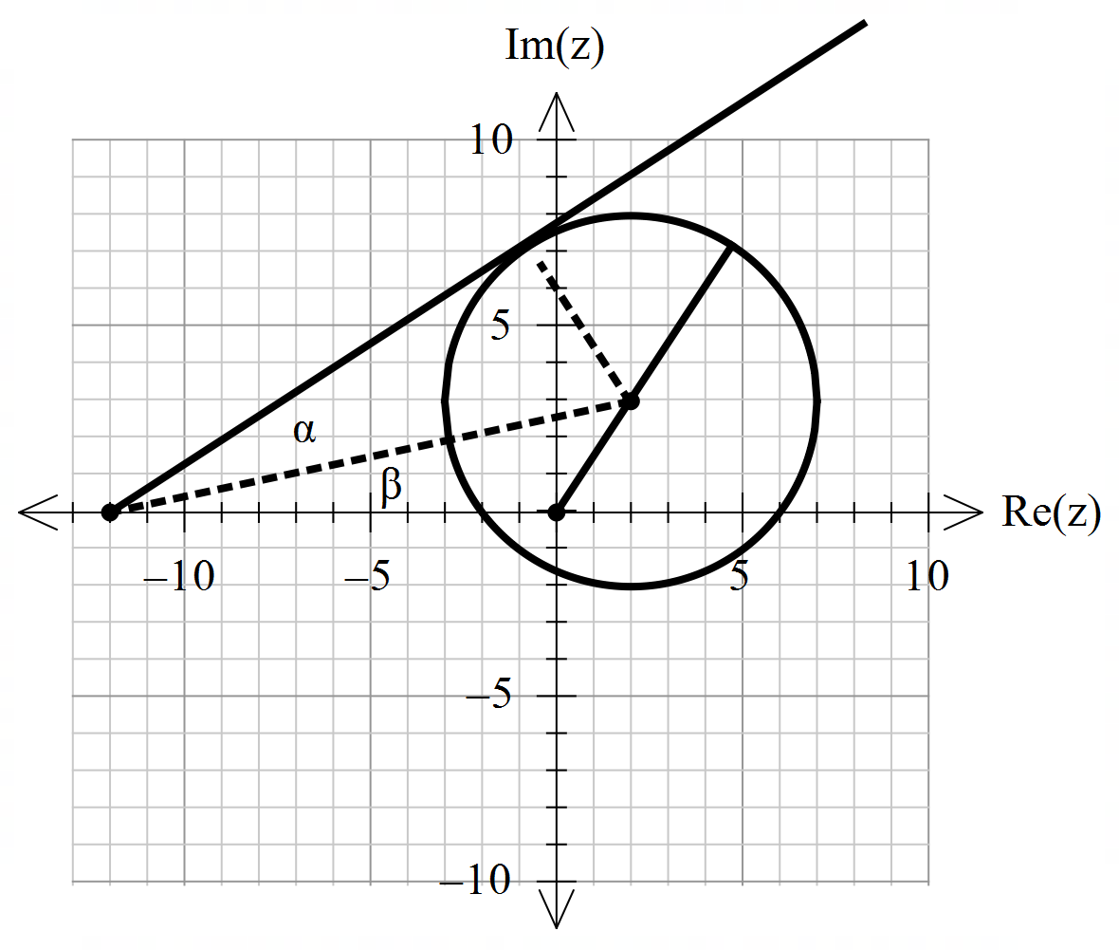
- Determine the maximum value of .

8.605551275

Solution
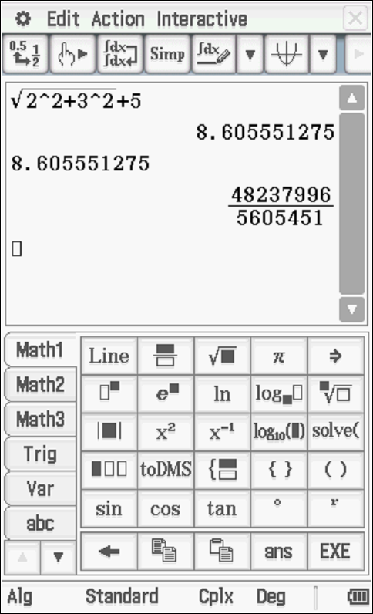

Specific behaviours
✓ determines modulus of centre
✓ adds radius (approx.)

- Determine the maximum value of the .

Solution
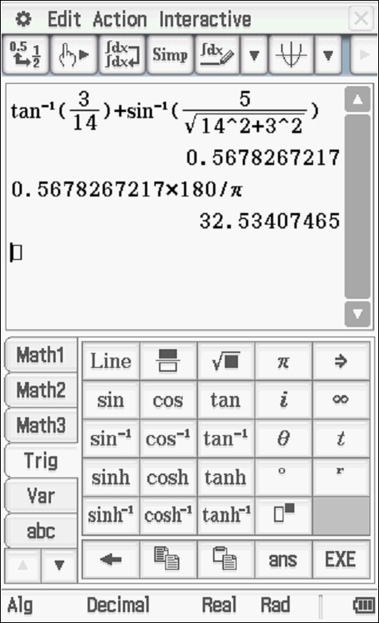

Specific behaviours
✓ uses tangent line from (-12,0)
✓ determines alpha angle
✓ identifies right angle for beta triangle and determines two side lengths
✓ determines sum of alpha & beta angles (see diagram)

Q7 (4 marks)
Using De Moivre’s Theorem, derive an expression for in terms of .

Solution
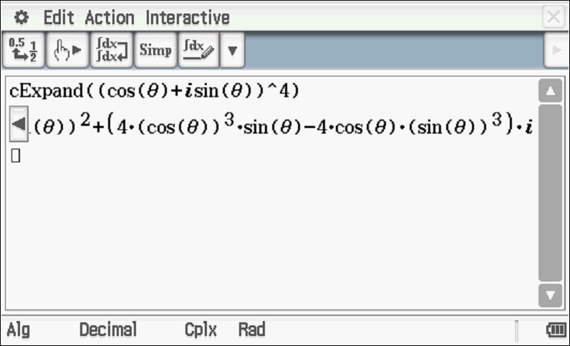

Specific behaviours
✓ sets up equation for power 4 and uses De Moivre’s
✓ states expression for power 4
✓ equates imaginary parts of both sides
✓ states required expression

Q8 (4, 2 & 3 = 9 marks)

- Solve for all the roots in polar form with .

Solution
Specific behaviours
✓ converts RHS to polar
✓ demonstrates use of De Moivre’s
✓ determines modulus of all roots
✓ determines principal arguments

- Plot these roots on the complex plane below.

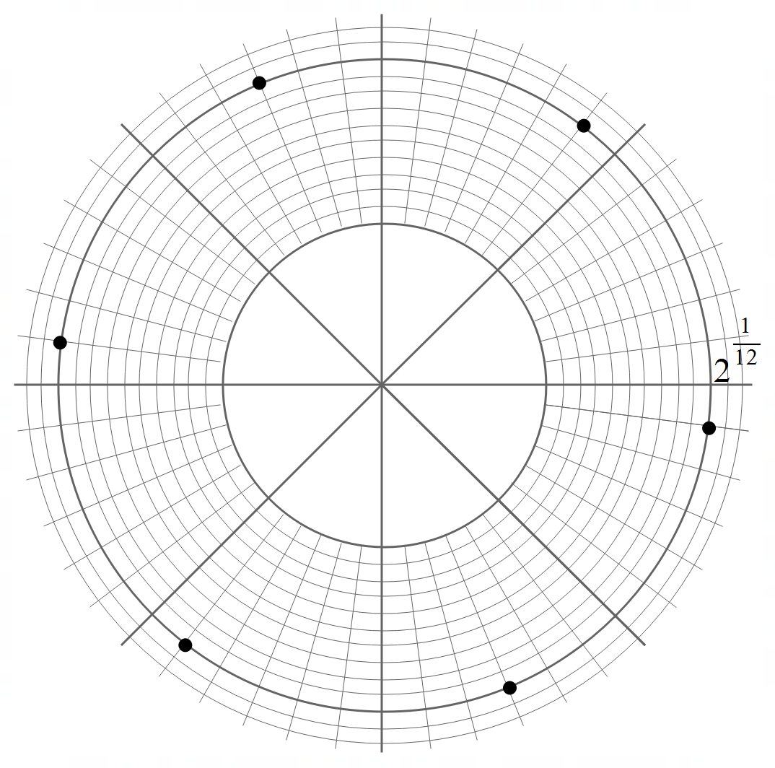

Solution
Specific behaviours
✓ shows scale and equally distance
✓ all positions correct

- Adjacent points can be joined by lines to form a polygon. Determine the exact area of this polygon.

Solution
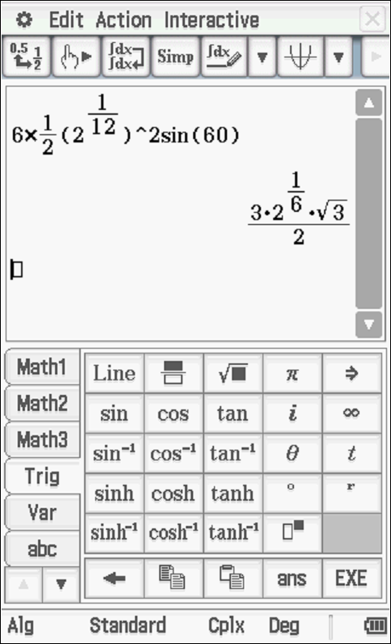

Specific behaviours
✓ identifies equilateral triangles
✓ determines side lengths
✓ shows calculation for total exact area

Working out space

Working out space

